**Welcome to Primary 1**



**Sidlaw View Primary School**

**Welcome**

We are looking forward to welcoming you to our school. You will already have copy of the school handbook, but this little booklet should help to familiarise yourself with what happens in P1. We hope it will help you prepare your child so that he or she starts school confidently, looking forward to making new friends and learning new things.

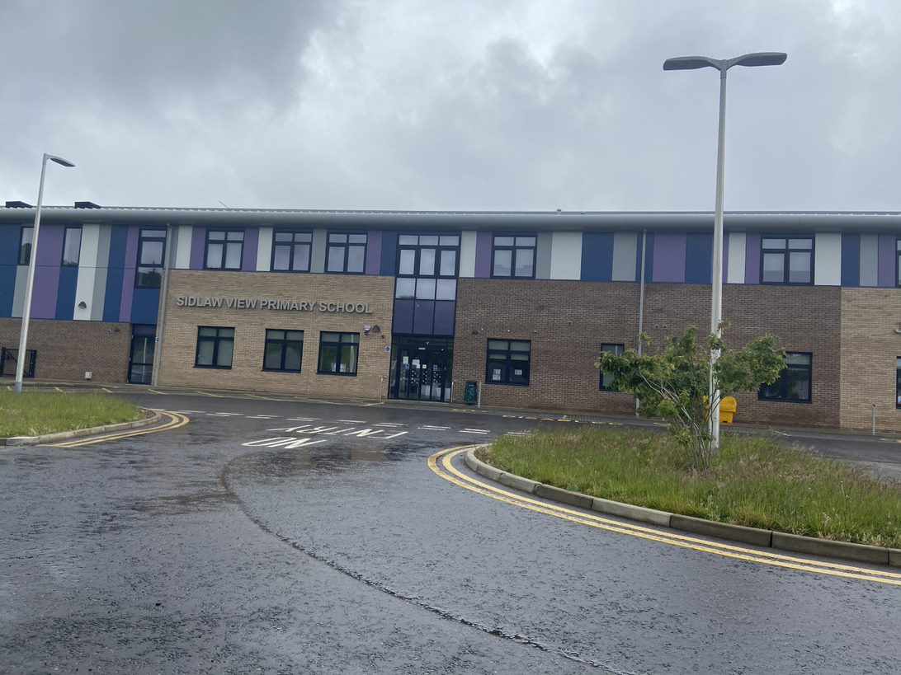



**Staff at Sidlaw View**

**Primary School**

**The Senior Leadership Team**

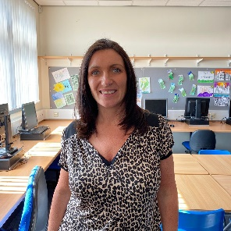

**Mrs Kim Flynn – Head Teacher**

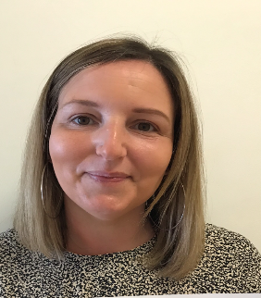

**Mrs Ashley Matheson – Depute Head Teacher**



**Miss Susan Cruickshank – Principal Teacher**

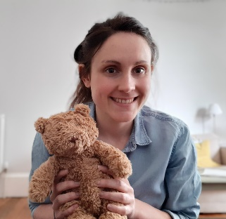 **This is your Primary 1 Class Teachers**

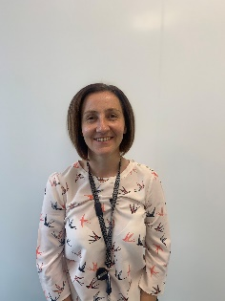

**Miss Fiona Callaghan**

**Mrs Jaime Biltcliffe**

**Working Together**



At Sidlaw View Primary School

we believe it is important for

parents and teachers to work

together for the benefit of

every child.

You are the first educators of your child and your contribution is very valuable. We are sure you will continue to support your child’s learning and progress in school.



[This Photo](https://sasithebeginner.blogspot.com/2011/09/true-love.html) by Unknown Author is licensed under [CC BY-NC-ND](https://creativecommons.org/licenses/by-nc-nd/3.0/)

We recognise the importance and variety of your child’s

experiences from home and nursery and wish to build on

them in a positive way. The understanding you have of your child is unique. We would appreciate if you could complete an ‘All About Me’ booklet before your child starts P1 so we can find out a little bit more about them.



[This Photo](http://blogdemajeperez.blogspot.com/2015/09/all-about-me.html) by Unknown Author is licensed under [CC BY-NC-ND](https://creativecommons.org/licenses/by-nc-nd/3.0/)

**Seesaw**

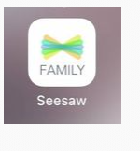In our school, we use Seesaw to communicate with home. Seesaw provides a great platform for sharing your child’s learning from home and school. Each Seesaw profile has a journal feature which will be used to share evidence of your child’s learning. Your child will also be provided with homework bag to carry their homework, reading book and letters to and from school. No food or drink should be carried in this bag.

If you want to discuss or inform the school of

anything regarding your child, please do not

hesitate to phone the school to arrange an

appointment or get in touch via Seesaw.

Please copy the link below to access more information about downloading the Seesaw Family and Class app. This can also be found on our school website

<https://app.bookcreator.com/books/OnhVBZ_VQaeVkjPfujov6g/6jtU9d6sTB6oy1GrcA2H9Q>

**The Importance of Reading and Developing Vocabulary**

We value your input!

* Parent/Carers are key to helping children achieve. Children who read at home with an adult make the best progress and develop a more enriched vocabulary.
* If children learn to associate books with special, individual time with a parent, they are more likely to be positive about books and to look forward to their reading time.
* At home, children can read at their own pace and take time to look at the pictures and talk about what they are reading.
* More information will be sent home with your child when they get their first reading books home.
* **Research shows that the single most important thing a parent can do to support their education is to read to and read with your child.**

There are many advantages in having parents support their children’s learning. Here are some guidelines on how you can help.

There is a lot of work to be done before children are ready to read. These guidelines will encourage your child to enjoy books and give them the confidence to tackle reading in a more formal setting.

**S**pend quality time together.

**E**ncourage your child to read for fun*

**L**isten carefully to your child’s ideas.

**F**ind ways to encourage your child’s efforts.

**E**njoy family activities and projects.

**S**hare favourite books and stories.

**T**alk to your child often.

**E**stablish a daily read-aloud time*

**E**ngage your child in natural reading activities*

**M**odel the act of reading for your child.

*Reading can mean simply looking at pictures or identify what is printed text.

**Learning to Read**

We approach learning to read in many different

ways. For example, word recognition, picture

clues and phonics. Phonics is not the only way to

learn to read but it is important as it helps to

facilitate word-building skills and therefore

makes it easier for children to decode new words.

As part of the Read Write Inc programme (RWI)

your children will be taught the sounds in

this order:-

RWI set 1

m, a, s, d, t

i, n, p, g, o

c, k, u, b,

f, e, l, h, sh,

r, j, v, y, w, th, z

ch, qu, x, ng, nk

They have been selected in this order so that children can begin word building as soon as they have learned the first five letters e.g. “sat” and “mad”.

**Learning to Write**

At the same time as learning to say sounds, children will learn to write them. They are taught to write lower case letters first.

**Here is a guide t**o the correct letter formation. Follow the arrows, all letters are on continual line except for the “x”, dotting the “i” and “j” and crossing the “t” and “f”. The children will learn a story to help with the forming of each lower case letter – e.g. *down Maisy mountain, mountain* - when forming ‘m’.



**The Importance of Numeracy**



We value your input!

Maths knowledge can be consolidated at home as

part of everyday communication with your child.

Here are some suggestions:-

* Board Games – can help with counting and sequencing of number as well as social skills, like turn taking.
* Number songs and rhymes – can help children remember number names.
* Shapes in the environment – will make your child familiar with shape names, e.g. a rectangle window, a road sign the shape of a circle.
* Playing shops or spending pocket money – will help children recognise coins.
* Sorting and matching – e.g. cards, marbles, setting the table are good pre data handling skills.
* Measure language – e.g. long, short, heavy, light, thick, thin, etc.
* Discuss – clocks, watches and days of the week, this will introduce the concept of time to your child.
* Encourage your child to count as much as possible – e.g. when walking up the stairs, the amount of pasta in a jar, etc.



[This Photo](http://myedmondsnews.com/2014/03/state-fire-marshal-reminder-change-clocks-change-batteries/wall_clock_three) by Unknown Author is licensed under [CC BY](https://creativecommons.org/licenses/by/3.0/)

**The School Day**

A normal school day a Sidlaw View

begins at 9 o’clock sharp. A warning bell rings at 8.58am

to tell our pupils that it is time to line up in the playground. When the bell rings at 9 o’clock, teachers will meet the classes and take them into school.

Our playtime is between 10.30 and 10.45am.

Our lunchtime is from 12.15 to 1.15pm.

School finishes at 3.15pm for all pupils.

All primary 1 pupils should be collected from school by a responsible person known to the school. E.g. Parent, older sibling, or another known adult.

**School Uniform**

We strongly promote the wearing of school uniform to promote a sense of belonging to a community and of pride in our school. There is quite a choice of items.

**Girls**

* White blouse
* School tie
* Charcoal grey skirt/pinafore/trousers
* 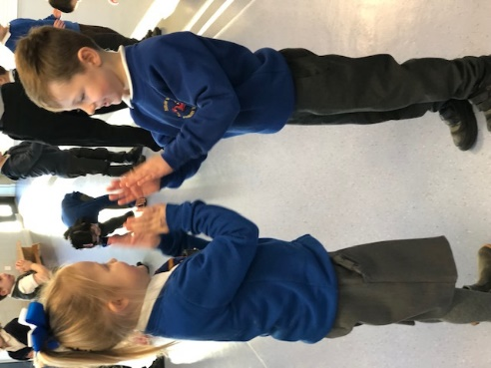Royal blue or grey sweatshirt, ‘v’ necked jumper, tank top or cardigan with school logo.
* Blue stripe/check dress (summer)
* Plain black shoes/trainers

**Boy**

* White shirt
* School tie
* Grey trousers
* Royal blue or grey sweatshirt with school logo,

or ‘v’ necked jumper

* Plain black shoes or trainers

**No hooded jumpers are permitted**

School uniform is available from the Schoolwear shop, Meadowside, Dundee.



Both boys and girls should wear substantial black shoes, boots or wellingtons, depending on the weather.

**Only black trainers are acceptable.**

All children require a pair of gym shoes for indoor activities. Please ensure you write the child’s name on

both shoes. It would also be helpful if your child had an

old shirt/t-shirt for art and craft work.

**Gym Kit**



[This Photo](http://en.wikipedia.org/wiki/File:Polo_Shirt_Basic_Pattern.png) by Unknown Author is licensed under [CC BY-SA](https://creativecommons.org/licenses/by-sa/3.0/)

Please provide your child with

black shorts and a plain white

t-shirt for PE.

It is helpful if these are put into

a drawstring bag and left in school

during the week.

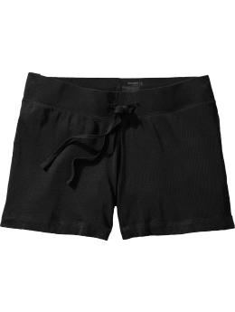

[This Photo](http://novarella.blogspot.com/2010/12/dear-mom-and-everyone-else-i-guess.html) by Unknown Author is licensed under [CC BY](https://creativecommons.org/licenses/by/3.0/)

It is Dundee City Council policy that **no**

jewellery is to be worn in the gym for safety reasons.

This includes pierced earrings.

Staff are not permitted to remove or

replace pupils’ earrings. Jewellery should be kept to a minimum on all other days. If earrings cannot be removed, parents/carers should supply elastoplast to cover the earrings for gym.

Children are responsible for their own belongings.

It is extremely important that your child’s name is

clearly marked on all articles of

clothing, footwear, school bag and

packed lunch container – many items

are often mislaid-a name helps so much!



**Eating and Drinking**

**Lunch**

Included in the pack is a lunch menu.

Please support your child to choose a meal of their



[This Photo](http://www.pngall.com/lunch-box-png) by Unknown Author is licensed under [CC BY-NC](https://creativecommons.org/licenses/by-nc/3.0/)

choice. **All P1 – P3 pupils are entitled**

**to a free school meal**. However, if you prefer you can give your child a packed lunch.

**Health Promoting School**

Many of our pupils bring a small

snack for interval. Please don’t

give your child chewing gum



[This Photo](http://www.dailyclipart.net/page/4/?s=orange&search_x=0&search_y=0) by Unknown Author is licensed under [CC BY-ND](https://creativecommons.org/licenses/by-nd/3.0/)

or fizzy drinks – for safety

reasons. We are

encouraging healthy eating

choices within the school. It

would help greatly if your

child’s snack was in line with

this policy.

**Toothbrushing**



We participate in Tayside Health Board’s

toothbrushing initiative. Children brush their

teeth once a day with the help and support of

an adult. This should help to form good habits

for the future.

**Water**

Children are permitted to bring in a

water bottle from home. The bottle

should be washed daily at home

and filled up with water before

coming to school. We encourage

our pupils to stay hydrated by

drinking water – this

helps concentration. They can

be refilled during the day from our

chilled water fountain in the

infant department.

**Communication**



[This Photo](http://2017.igem.org/Team:Macquarie_Australia) by Unknown Author is licensed under [CC BY](https://creativecommons.org/licenses/by/3.0/)

Newsletters, flyers about activities, pupil reports and other written communication go home regularly from school. Please check your child’s bag every day - children do not always remember to give them to you! We also try to keep parents/carers updated through Twitter. Please follow us on **@SidlawViewPS**

**School Website**

Please visit our newly created school website

**sidlawview.ea.dundeecity.sch.uk**

**Absences**

Good attendance is essential

for learning – both academic

and social. On occasion

your child may be unwell or

have to be absent from school

for medical appointments or

other essential reasons. Please

contact the school on the first day

of absence to let us know what is

wrong and how long you expect your

child to be absent. The school also

send out information through text.

Parents can reply to text messages.

The school phone number is **436458.**

**Security**

Our pupils’ safety is vital to us. All visitors,

including parents, must use the main entrance

at the front of the school. This is the only way

people can enter as all doors are kept locked.

Please ring the bell and wait for a response.

Once in, all visitors must report to the school

office where a member of staff will be happy to

help. **Parents should not use the school car**

**park in order to ensure that all children are**

**safe in the school grounds.**

**Breakfast Club**

Breakfast Club opens at



[This Photo](http://myenglishblogmartagomez.blogspot.com/) by Unknown Author is licensed under [CC BY-NC-ND](https://creativecommons.org/licenses/by-nc-nd/3.0/)

8.00am until the bell

rings at 9.00am. Further information

is available through the school office. It should be noted that he breakfast club spaces are limited and there are very few available spaces on a yearly basis therefore it should not be relied upon for child care.

**Parent Pay**

You will be provided with a log on and password

for Parent Pay. This is a digital platform which is used for collecting any monies for the school, including breakfast club, School Dinners (from p4-7) and trips etc. We encourage all parents to download and use this app.

**Positive Behaviour Reinforcement**



At Sidlaw View our vision is to be the

**B**elieve

**E**njoy

**S**ucceed

**T**ogether

There are several ways used consistently across the school to promote our Vision, Values and Aims.

* Weekly assemblies are held where head teachers’ awards are given.
* Hot Chocolate Friday happens each week. A child from each class is chosen to have hot chocolate in the staffroom as recognition for consistently exceeding expectations. This is a very popular treat!
* “Above and Beyond” recognition boards are used in every class. As a class, children encourage each other to aim to be the best- when each name is moved to “Above and Beyond” this achievement is celebrated.
* Marble Jars, the children work together to fill a marble jar. Once the jar is full, the class can enjoy a treat such as an extra playtime, a movie or extra choosing time.

**And Finally…**

Be reassured that the atmosphere in our school is happy, relaxed and supportive and the staff will help your child settle happily into school life. We look forward to seeing you and we hope you have a safe and relaxing summer.

